Quantum Machine Learning Analysis
Eric Gomez
270856490
26/07/2026
MSE802

Table of Contents

1. Introduction 2
2. Analysis of the Circuit and the Input Data 2
3. Execution and Iteration Monitoring 3
4. Local Execution and Performance Disparities 5
5. Conclusion 7
6. References 7
7. Figures 7
8. Tables 8

Introduction

The purpose of this report is to document the analysis and modification of the quantum machine learning code provided for Task 4. The provided code trains a parameterised quantum circuit to distinguish two families of binary images, bars and stripes, by adjusting six rotation angles with the Simultaneous Perturbation Stochastic Approximation (SPSA) optimiser (Spall, 1992). The brief requires three outcomes: an analysis of the circuit and of the data that enter it, an instrumented execution in which the objective value and the wall-clock time of every iteration are recorded and plotted, and a modification that removes the dependency on the remote Quokka device so that the code runs on the local machine, together with a measurement of the resulting disparities in performance.
The modified notebook, Quantum_ML_AS2.ipynb, is submitted alongside this report; every figure and number presented here was produced by executing that notebook in Visual Studio Code on the local machine, using the conda environment qiskEnv (Python 3.11.15, Qiskit 2.4.0 with the Aer simulator) (Qiskit Contributors, n.d.). The random seed is fixed at 802 so that the run can be repeated: in the repeats performed for this report, executing the notebook again reproduced the printed objective values, whereas the wall-clock timings varied with the load of the machine at the time of execution.

Analysis of the Circuit and the Input Data

The data set is generated by the provided code and consists of four images of 2 x 2 pixels; each image is constant along one axis, so that the two column-constant images form the stripe class (label 0) whereas the two row-constant images form the bar class (label 1), as Figure 1 shows. Three images are selected at random for training and the remaining image is held out in order to test generalisation. Because every pixel is mapped to one qubit, the circuit acts on four qubits, and the number of trainable parameters is six, two rotation angles for each of the three entangling blocks.

Figure 1.
The four bars and stripes images with their class labels.
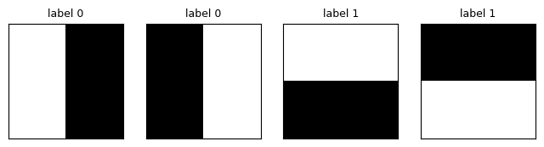
Figure 2 presents the circuit for the first stripe image with all angles set to zero, and the analysis identifies three stages. The input stage is the block of conditional x gates: for every pixel whose value exceeds 0.5 the corresponding qubit is flipped, hence the image is written into the register as a computational basis state. The pixels are therefore the data that enter the circuit, and these conditional x gates are the portion of the code that serves as the input layer. The trainable stage consists of three blocks, each containing two parameterised ry rotations followed by a cx gate that entangles the pair; the blocks are arranged over the qubit pairs (0, 1), (2, 3) and (1, 3) in a binary-tree pattern of logarithmic depth (Grant et al., 2018). The readout stage measures only qubit q3; the mean of the returned bits estimates P(1), the probability that the readout qubit collapses to 1, and this single scalar is the output of the model (Nielsen & Chuang, 2010). The objective function averages the distance between P(1) and the label over the images, whereas the optimisation algorithm itself is entirely classical and is therefore excluded from this analysis, as the brief instructs. Every circuit is expressed as an OpenQASM 2.0 program (Cross et al., 2017), the format that the Quokka device accepts and that the local simulator can execute unchanged.

Figure 2.
The four-qubit model circuit for the first stripe image with all angles set to zero.
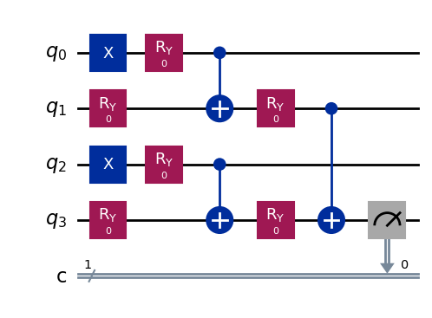

Execution and Iteration Monitoring

The provided SPSA implementation, which is the classical half of the hybrid loop, was instrumented so that the objective value and the duration of every iteration are recorded: after each parameter update the objective is evaluated once more with 1000 shots per image, which produces a learning curve less affected by shot noise than the 100-shot evaluations used for training, and the duration of each iteration is captured with a monotonic clock. The training configuration follows the provided code: 100 shots per image during training, SPSA settings a = 1, c = 0.5, alpha = 0.602 and gamma = 0.101, and 100 iterations. The printed output of every tenth iteration is reproduced below.
Iteration 0: f = 0.4443
Iteration 10: f = 0.3040
Iteration 20: f = 0.2170
Iteration 30: f = 0.0780
Iteration 40: f = 0.0273
Iteration 50: f = 0.0137
Iteration 60: f = 0.0063
Iteration 70: f = 0.0027
Iteration 80: f = 0.0010
Iteration 90: f = 0.0003
final objective = 0.0003 (total training time 0.3 s)

Figure 3 plots the iteration number against the objective value. The curve falls steeply during the first thirty iterations, while the gain sequence is still large, and subsequently flattens as the objective approaches zero; the final value of 0.0003 indicates that the optimiser converged in this run. Figure 4 plots the iteration number against the wall-clock time of each iteration for the submitted run; the cost remains close to two milliseconds throughout, which is expected because every iteration executes the same workload of two objective evaluations, and consequently the total training time grows linearly with the iteration count.

Figure 3.
Iteration number against the objective value (1000-shot estimate).
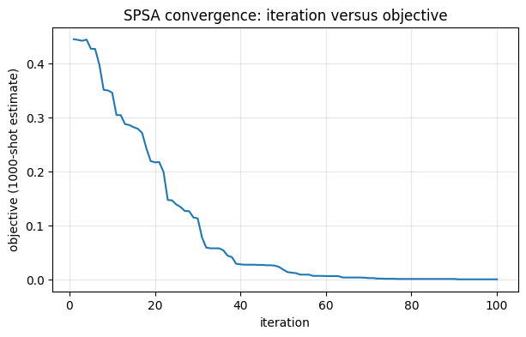

Figure 4.
Iteration number against the wall-clock time per iteration for the submitted run.
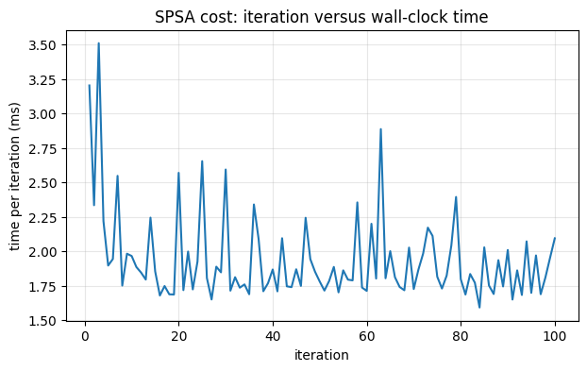
In order to check reproducibility the notebook was executed repeatedly. The objective curve and the printed values were identical across the repeats performed, as expected from the fixed seed, whereas the timing plot varied slightly from run to run, as Figure 5 illustrates for an independent repeat; wall-clock time reflects the load of the machine rather than the computation itself.
Figure 5.
Wall-clock time per iteration for an independent repeat of the same run.
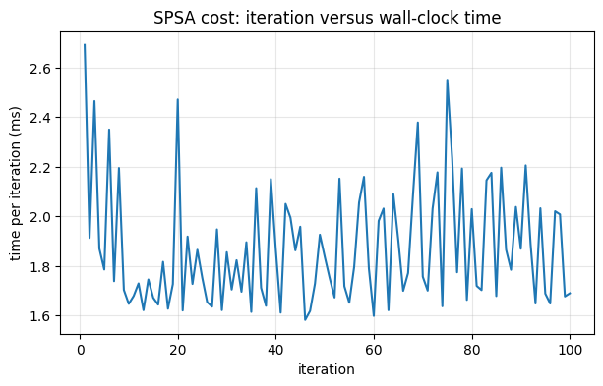

Local Execution and Performance Disparities
In the provided code every objective evaluation posts its circuits to the Quokka device over HTTP and waits for the reply. The modification replaces this network call with a single function, run_qasm_local, which executes the identical OpenQASM string on the Qiskit Aer simulator; no other line of the objective changes, therefore the model, the cost function and the optimiser remain exactly those of the provided code, and the need for the quantum computer is removed. The original remote objective is retained in the final section of the notebook so that the two execution modes can be compared directly; during the recorded run the Quokka unit was online, hence the comparison below was measured rather than estimated (Quokka Computing, n.d.).
local evaluation: 1.4 ms (objective = 0.0000)
Quokka evaluation: 0.85 s (objective = 0.0000)
ratio: the remote evaluation is 615x slower
projected 100-iteration training on Quokka: 2.8 min (local: 0.3 s)

Table 1
Efficiency and Effectiveness of the Two Execution Modes
Execution mode | One objective evaluation | Objective value | Training (100 iterations)
Local (Aer simulator) | 1.4 ms | 0.0000 | 0.3 s (measured)
Remote (Quokka device) | 0.85 s | 0.0000 | 2.8 min (projected)

Efficiency differs by more than two orders of magnitude: the local evaluation of the three training images completes in 1.4 milliseconds, whereas the identical evaluation on the device takes 0.85 seconds, a factor of roughly six hundred (615 in the recorded run), because each remote evaluation pays one HTTP round trip per image to a device exposed through a tunnel. Effectiveness, by contrast, showed no measurable difference in this comparison: the remote and the local evaluation of the trained model returned the same objective value, which is consistent with the endpoint behaving as a noise-free emulator sampling the same distributions as the local simulator, and agrees with the results recorded in Task 2 of this assessment. It is necessary to clarify that a single evaluation of an already converged model is a limited test; the equivalence is therefore an observation from one run rather than a general proof.
Table 2 reports the effectiveness of the trained model directly: every image is evaluated with 1000 shots, a score above 0.5 is read as class 1, and all four images, including the held-out test image, are classified correctly; the model therefore classifies correctly a pattern the optimiser never saw, although a single held-out image provides only limited evidence of generalisation.
Table 2
Predictions of the Trained Model at 1000 Shots per Image
Image (pixels) | Role | True label | P(1) | Result
[0 0 1 1] | training | 1 | 0.999 | correct
[1 0 1 0] | training | 0 | 0.000 | correct
[0 1 0 1] | training | 0 | 0.000 | correct
[1 1 0 0] | test | 1 | 0.997 | correct

Conclusion

The analysis identified the three quantum stages of the provided code: basis encoding through conditional x gates, which constitutes the data input; trainable two-qubit blocks arranged as a binary tree; and the measurement of a single readout qubit whose probability of collapsing to 1 is the output of the model. The instrumented execution recorded the objective value and the duration of all 100 SPSA iterations, and the resulting plots show convergence from 0.4443 to 0.0003 at an essentially constant cost of about two milliseconds per iteration. The local modification replaced the network call with the Aer simulator without altering the model, and the measured disparity between the two execution modes is confined to efficiency, a factor of several hundred in execution time, whereas no difference in effectiveness was observed in the recorded comparison. The task therefore demonstrates the hybrid character of variational quantum machine learning: the quantum circuit evaluates the model, the classical optimiser improves it, and in this task the executing backend was exchanged without changing the measured objective.

References
Cross, A. W., Bishop, L. S., Smolin, J. A., & Gambetta, J. M. (2017). Open Quantum Assembly Language. arXiv. Retrieved July 26, 2026, from https://arxiv.org/abs/1707.03429
Grant, E., Benedetti, M., Cao, S., Hallam, A., Lockhart, J., Stojevic, V., Green, A. G., & Severini, S. (2018). Hierarchical quantum classifiers. npj Quantum Information, 4, Article 65. https://doi.org/10.1038/s41534-018-0116-9
Nielsen, M. A., & Chuang, I. L. (2010). Quantum computation and quantum information (10th anniversary ed.). Cambridge University Press.
Qiskit Contributors. (n.d.). Qiskit: An open-source framework for quantum computing (Version 2.4.0) [Computer software]. IBM Quantum. Retrieved July 26, 2026, from https://www.ibm.com/quantum/qiskit
Quokka Computing. (n.d.). Quokka: The quantum computer for everyone. Retrieved July 26, 2026, from https://www.quokkacomputing.com
Spall, J. C. (1992). Multivariate stochastic approximation using a simultaneous perturbation gradient approximation. IEEE Transactions on Automatic Control, 37(3), 332-341. https://doi.org/10.1109/9.119632

Figures
Figure 1. The four bars and stripes images with their class labels.
Figure 2. The four-qubit model circuit for the first stripe image with all angles set to zero.
Figure 3. Iteration number against the objective value (1000-shot estimate).
Figure 4. Iteration number against the wall-clock time per iteration for the submitted run.
Figure 5. Wall-clock time per iteration for an independent repeat of the same run.

Tables
Table 1. Efficiency and Effectiveness of the Two Execution Modes.
Table 2. Predictions of the Trained Model at 1000 Shots per Image.

